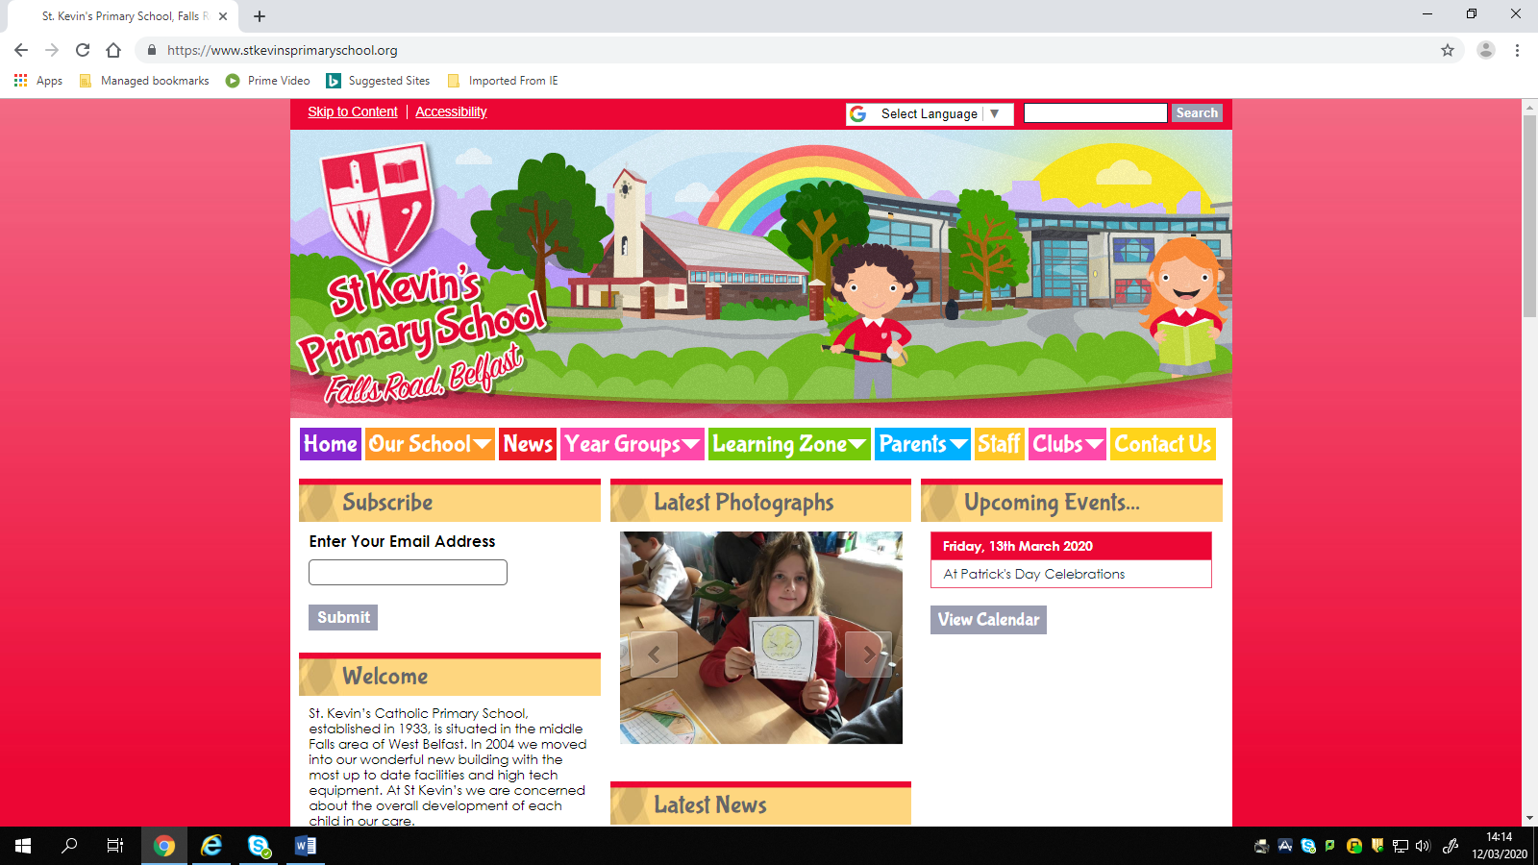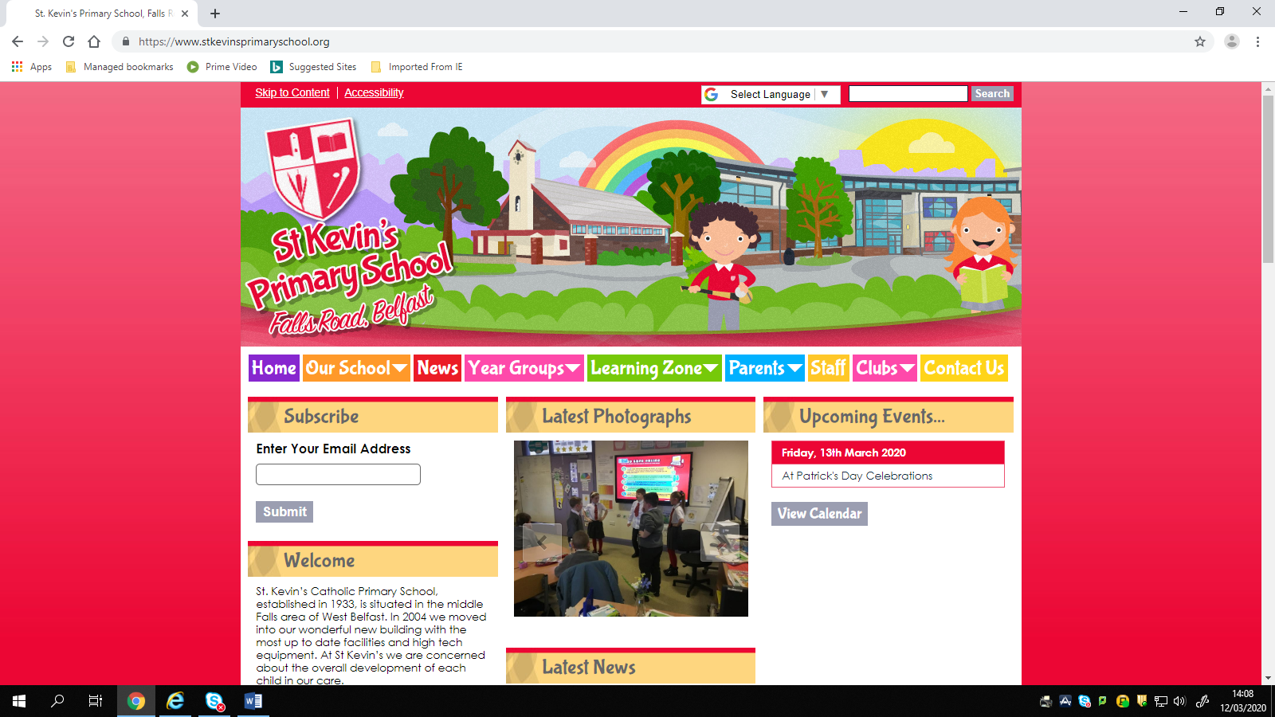

**Covid – 19 Update 13 March 2020**

In light of the Government decision to keep all schools open we will continue to monitor the situation closely. Please check your text messages and the school website regularly. I will also post any updated information on the St John’s Parish Facebook page.

Many thanks,

Miss Keegan

St. Kevin’s Primary School, 446 Falls Road, Belfast, Northern Ireland, BT12 6EN  
   
Tel: 02890 326 791

<https://www.stkevinsprimaryschool.org/>