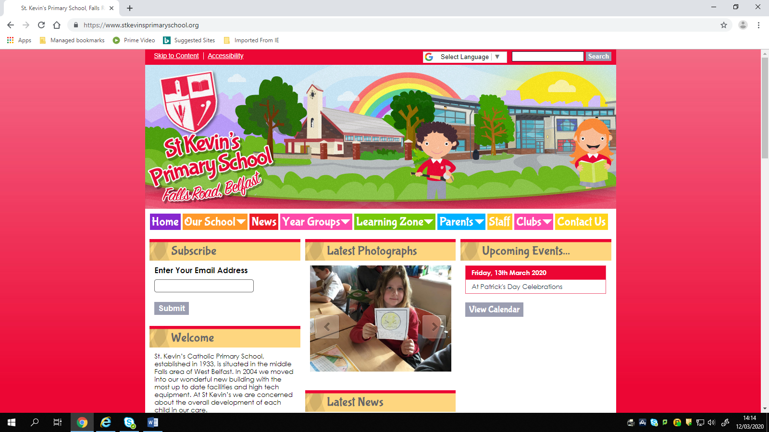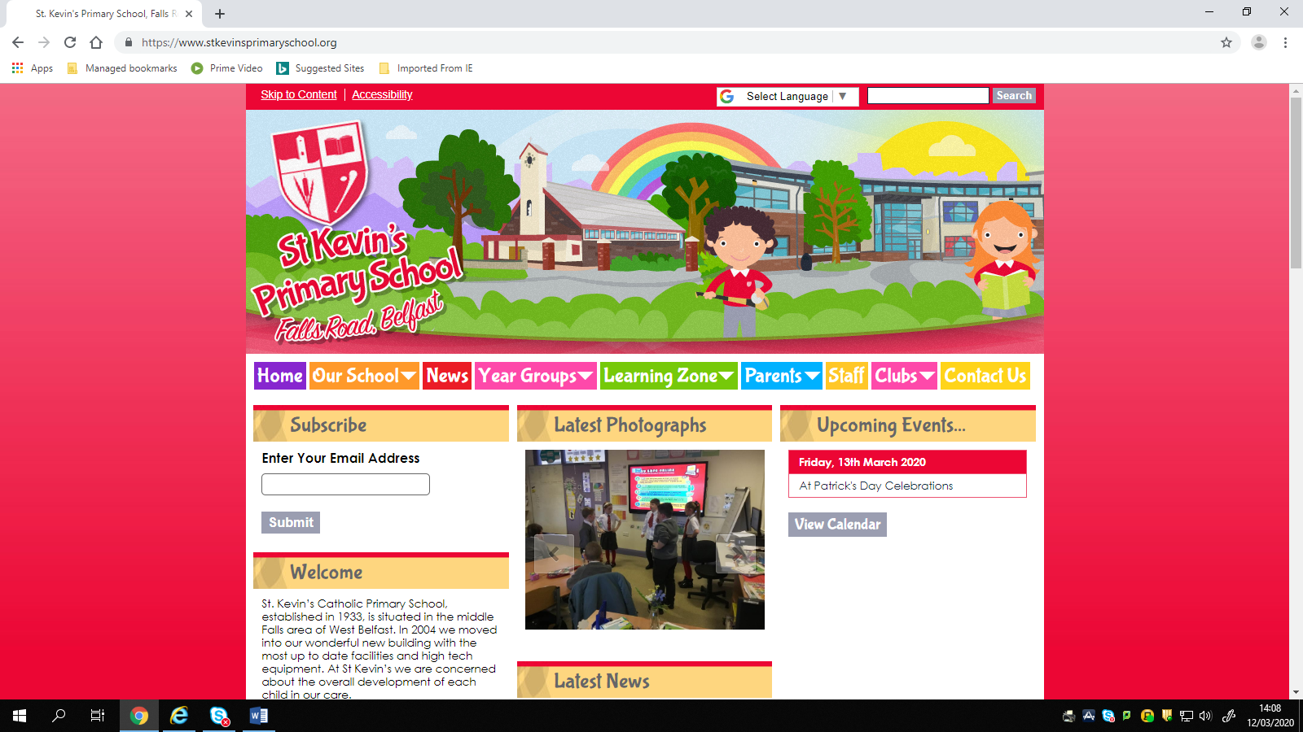

**Covid – 19 Directive regarding Sacraments**

We have been advised that the Bishop has suspended First Confession, First Communion and Confirmation. We will keep parents updated as we receive more clarification.

Many thanks,

Miss Keegan

St. Kevin’s Primary School, 446 Falls Road, Belfast, Northern Ireland, BT12 6EN  
   
Tel: 02890 326 791

<https://www.stkevinsprimaryschool.org/>